International Islamic University
Department of computer science

Assignment No. 2

Submitted To: Ms. Parkha Bashir
Submitted By: Mobeena Ramzan
Registration No: 3868-FBAS/BSCS/F18
Section: b

Question no: 1
Staff.h
#pragma once
#include<iostream>
using namespace std;
class staff
{
int staffid;
public:
staff()
{
staffid = 0;
}
staff(int i)
{
staffid = i;
}
int get()
{
cout<<"enter staff id: ";
cin >> staffid;
return staffid;
}
};

professor.h
#pragma once
#include<iostream>
#include<string>
using namespace std;
#include "staff.h"
class professor:public staff
{
int departid;
string departname;
public:
professor():staff()
{
departid = 0;
departname = "";
}
professor(int id,string n,int i):staff(i)
{
departid = id;
departname = n;
}
int getid()
{
cout << "enter department id: ";
cin >> departid;
return departid;
}
string getname()
{
cout << "enter department name: ";
cin >> departname;
return departname;
}
};

visitingprofessor.h
#pragma once
#include<iostream>
#include<string>
using namespace std;
#include "professor.h"
class visitingprofessor :
public professor
{
int courses, salary;
public:
visitingprofessor()
{
courses = 0;
salary = 0;
}
visitingprofessor(int c,int s, int id, string n, int i):professor(id,n,i)
{
courses = c;
salary = s;
}
void set(int c, int s)
{
courses = c;
salary = s;
}
int totalsalary()
{
int total;
total = courses * salary;
return total;
}
void display(int t)
{
cout << "total salary of visiting professor: " << t << endl;
}
};

visitingprofessor.cpp
#include "visitingprofessor.h"
#include "professor.h"
#include "staff.h"
#include<iostream>
#include<string>
using namespace std;
int main()
{
visitingprofessor v;
professor p;
staff s;
int c;
cout << "for professor" << endl
<< "for visiting professor" << endl
<< "0: to EXIT" << endl;
int t, cou, sal;
do
{
cout << "enter your choice: ";
cin >> c;
switch (c)
{
case 1:
{
s.get();
p.getid();
p.getname();
break;
}
case 2:
{
s.get();
cout << "enter total no of courses: ";
cin >> cou;
cout << "enter salary per course: ";
cin >> sal;
v.set(cou,sal);
t=v.totalsalary();
v.display(t);
}
default:cout << "enter valid choice" << endl;
}
} while (c != 0);
system("pause");
return 0;
}

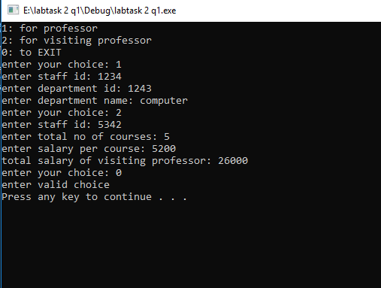
Result:

Question no 2:
graduatecourse.h
#pragma once
#include<iostream>
#include<string>
using namespace std;
class graduatecourse
{
string courseid,coursename;
int credithour, coursefee;
public:
graduatecourse(string i,string n,int h,int f)
{
courseid = i;
coursename = n;
credithour = h;
coursefee = f;
}
int course()
{
return coursefee;
}
void display()
{
cout << "course id: " << courseid << endl
<< "course name: " << coursename << endl
<< "credit hours: " << credithour << endl
<< "course fee: " << coursefee << endl;
}
};

researchcourse.h
#pragma once
#include<iostream>
#include<string>
using namespace std;
#include "graduatecourse.h"
class researchcourse :
public graduatecourse
{
int experimentfee;
public:
researchcourse(int e, string i, string n, int h, int f):graduatecourse(i,n,h,f)
{
experimentfee = e;
}
void set(int e)
{
experimentfee = e;
}
void display()
{
graduatecourse::display();
cout << "experiment fee: " << experimentfee << endl;
}
void totalfee()
{
int total;
total = experimentfee + graduatecourse::course();
cout << "total aggredated fee of course: " << total << endl;
}
};

reasearchcourse.cpp
#include<iostream>
#include<string>
#include "researchcourse.h"
using namespace std;
int main()
{
string i, n;
int cre, f,e;
cout << "enter course id: ";
cin >> i;
cout << "enter course name: ";
cin >> n;
cout << "enter credit hours of course: ";
cin >> cre;
cout << "enter course fee: ";
cin >> f;
cout << "enter experiment fee: ";
cin >> e;
researchcourse r(e,i,n,cre,f);
r.set(e);
r.display();
r.totalfee();
system("pause");
return 0;
}

Result:
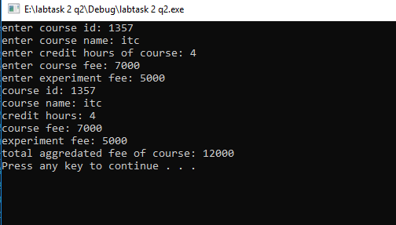

Question no 3:
restaurant.h
#pragma once
#include<iostream>
#include<string>
using namespace std;
class restaurant
{
string name;
int price;
public:
restaurant(string n, int p)
{
name = n;
price = p;
}
int getprice()
{
return price;
}
void display()
{
cout << "name of food item: " << name << endl
<< "price of food item: " << price << endl;
}
};

hotelservice.h
#pragma once
#include<iostream>
#include<string>
using namespace std;
class hotelservice
{
string service;
int fee,roomno;
public:
hotelservice(string s,int f,int r)
{
service = s;
fee = f;
roomno = r;
}
int getfee()
{
return fee;
}
void display()
{
cout << "name of service: " << service << endl
<< "fee of the service: " << fee << endl
<< "room number to which service id applied: "<<roomno << endl;
}
};

roomservicemeal.h
#pragma once
#include<iostream>
#include<string>
#include"restaurant.h"
#include"hotelservice.h"
using namespace std;
class roomservicemeal :public restaurant,public hotelservice
{
public:
roomservicemeal(string n, int p, string s, int f, int r):restaurant(n,p),hotelservice(s,f,r)
{
}
void display()
{
int t;
restaurant::display();
hotelservice::display();
t = restaurant::getprice()+hotelservice::getfee();
cout << "total of meal plus the room service: " << t << endl;
}
};

roomservicemeal.cpp
#include<iostream>
#include<string>
#include"restaurant.h"
#include"hotelservice.h"
#include "roomservicemeal.h"
int main()
{
string n,s;
int p,f,room;
cout << "enter the name of the food item: ";
cin >> n;
cout << "enter the price of the food item: ";
cin >> p;
cout << "enter the name of the service: ";
cin >> s;
cout << "enter the fee of the service: ";
cin >> f;
cout << "enter the room no to which the service is applied: ";
cin >> room;
roomservicemeal r(n, p, s, f, room);
r.display();
system("pause");
return 0;
}
